Create an interactive dashboard in tableau for the given data set and show the following

1. Sales by category
2. Sales Overtime
3. Sales across states
4. Sales by city

Solution

Import and connect Superstore sales data

Sheet 1: Sales by Category

Select Category and Sales from the data pane and drop them in Row and Column shelf respectively

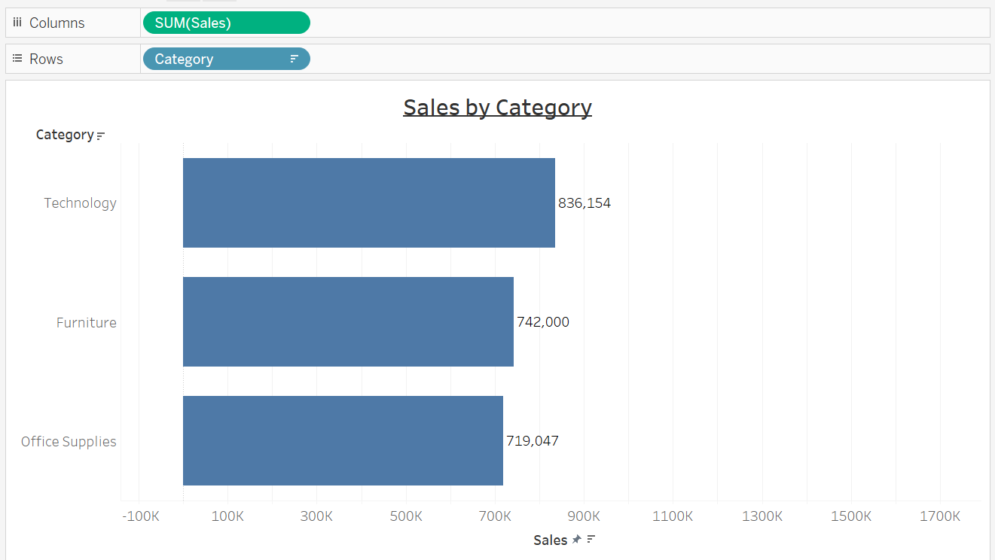

Sheet 2: Sales Overtime

Select Sales and drag to the Rows and drop Order Date into the columns.

Click on the + on year in the columns shelf. On clicking first, the Quarter will appear and on another click on the Quarter, Month will appear. Now drop the Year and Quarter. It will create a Month view of sales.

For month wise sales comparison over the years, that means how the performance in January 2016 in comparison to January 2017 was. To do this, pick Order Date from the data pane and drop it on the colors card.

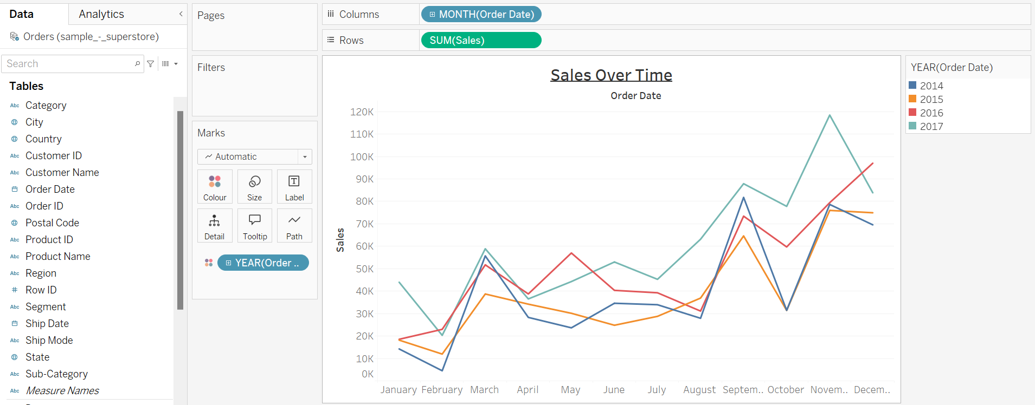

Sheet 3: Sales across States

Geospatial analysis

Select Sales and State by pressing ctrl+ click and click on show me.

Out of the recommended visualizations select the map. Click on the 49 unknown messages. Go to “Edit Locations” then go to country/Region, select “from field”. The United States will appear itself and click ok.

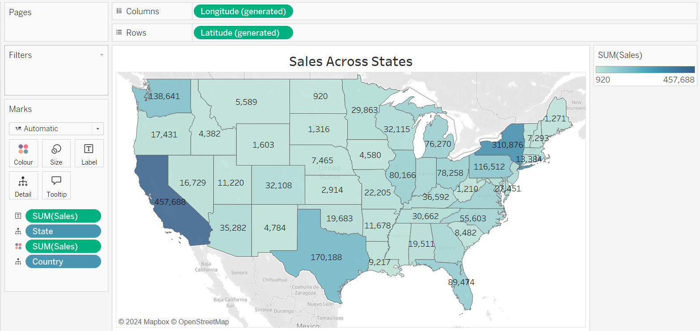

Sheet 4: Sales by City

Select Sales and City and click on the show me. Then click on the recommended visualization. Again we have 530 unknowns, click on that then edit locations. Go to the country and click on them from the field. You will see the United States poped out, click OK.

For a better idea of cities, select State from the data pane and drop it on the details card

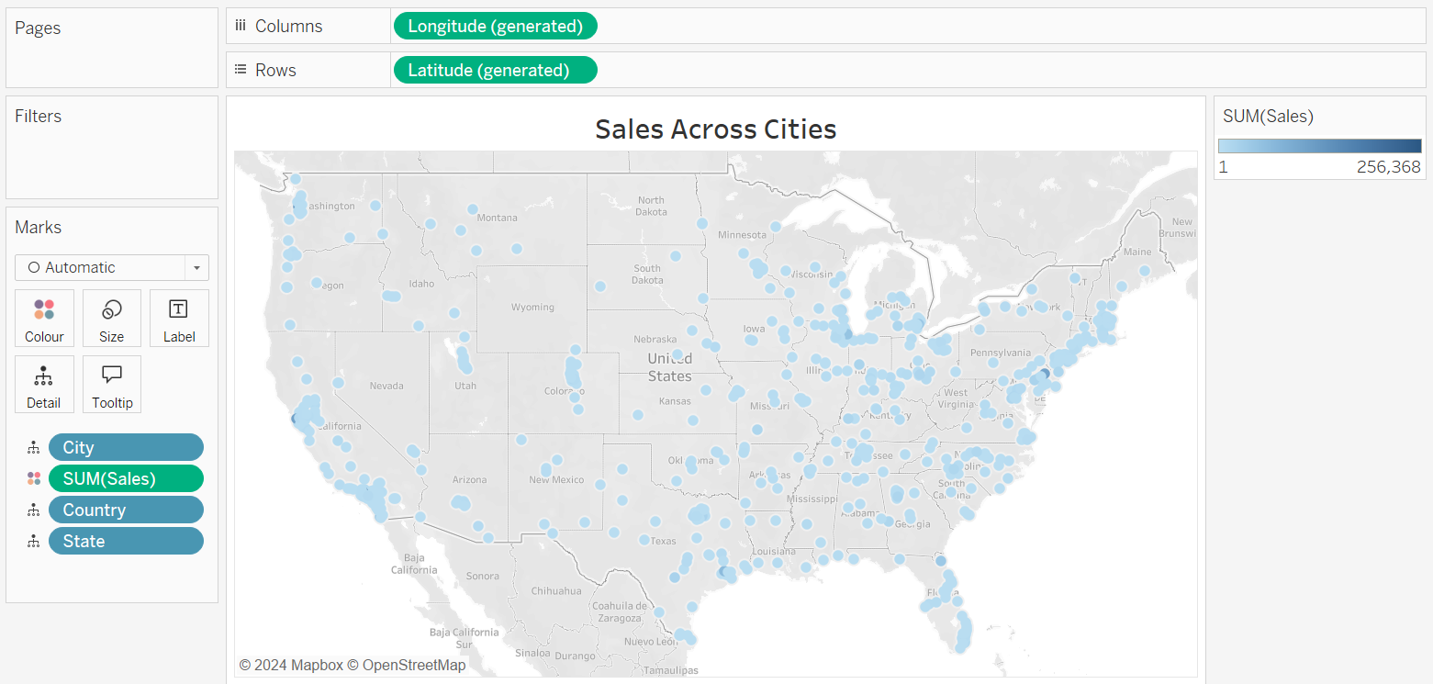

Create a Dashboard

To create a new dashboard click on the icon given on the bottom bar for showing the text ” New Dashboard”. When dashboard appears, all the created worksheets can be seen on a side panel.

In a dashboard, option to change the view of the dashboard can be chosen. It can be a default or a phone view. If the current half view of the dashboard need to be changed, then change this by clicking on the size drop-down and select automatically. Now drag and drop all the sheets from the sidebar to the dashboard.

